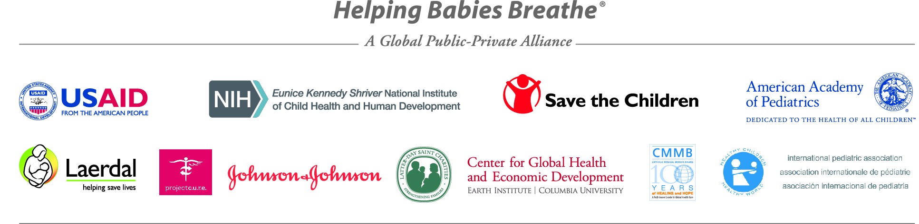

Annual Meeting of the HBB Global Development Alliance
AAP Headquarters, Elk Grove Village, IL
Monday, September 9, 2013
AAP Board Room
8:30am – 5:00 pm

8:30am | Continental Breakfast
9:00am | Welcome and Introductions | Errol Alden
9:15 | Summary Report on Achievements | Eileen Schoen
9:45 | Partner Discussion  What have you gained from the GDA?  Lessons learned/challenges  Suggestions for improvement? | All
10:45 | Global Newborn Initiatives  Every Newborn Action Plan (ENAP)  Status of Newborn Commodities under UN Commission for  Life Saving Commodities (resuscitation focus) | Lily Kak  Donna Vivio
11:15 | PATH report on quantification tools for UN Commission  Group feedback invited | Faye Venegas
12:15pm | LUNCH
1:00 | The Grand Scheme of Newborn Care  Integration of other programs | Tore Laerdal  Wally Carlo
1:30 | The Golden Minute and Beyond | Carl Bose
2:00 | Preterm Birth (Survive and Thrive program) | Nalini Singhal
2:15 | Helping Mothers Survive | Tore Laerdal
2:30 | Global Network Quality Improvement Overview  Case Studies  Discussion of Minimum QI Goals for HBB | Linda Wright  Joseph Johnson  All
3:30 | BREAK

9/9/2013 | Annual Meeting of the HBB Global Development Alliance | Page 2
3:45 | Implementation Discussion  Examples of national plans  How to achieve national scale-up | All
4:45 | Next steps | Lily Kak  George Little
5:00pm | Meeting close

Attachments:
- Implementation Matrix
- Compiled Partner Reports
- Attendee List

